NYC YELLOW TAXI ANALYTICS DASHBOARDS
February 2026 | Six-page Power BI dashboard

EXECUTIVE DASHBOARD

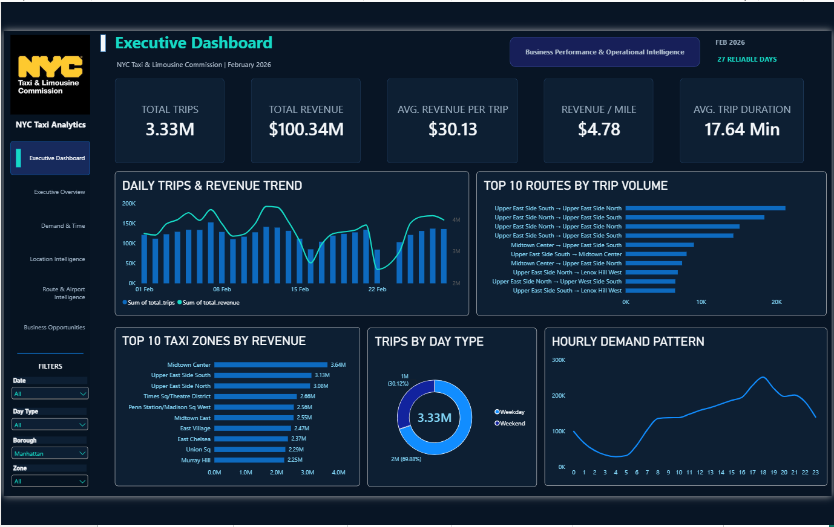

EXECUTIVE OVERVIEW

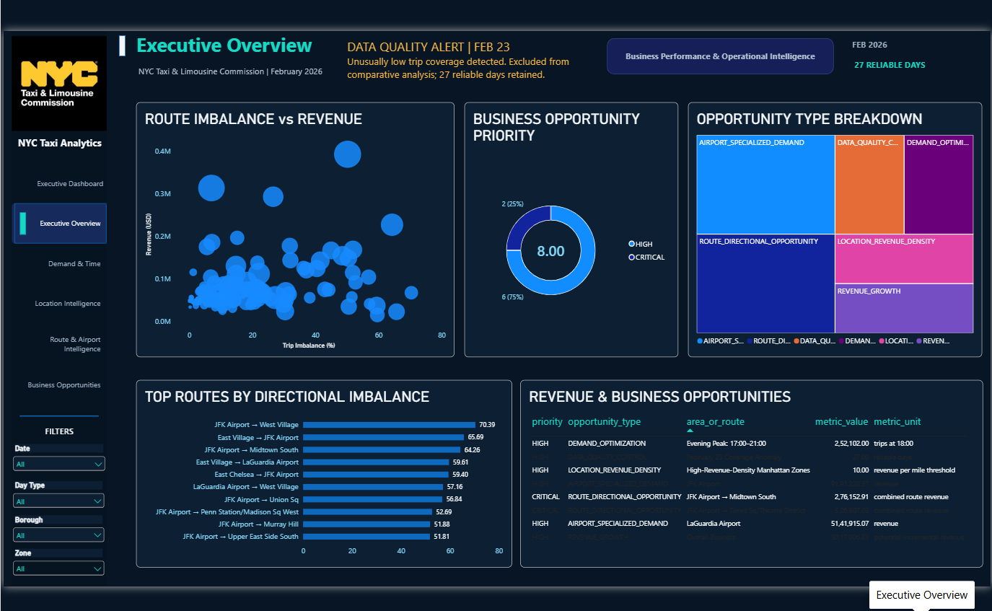

DEMAND & TIME INTELLIGENCE

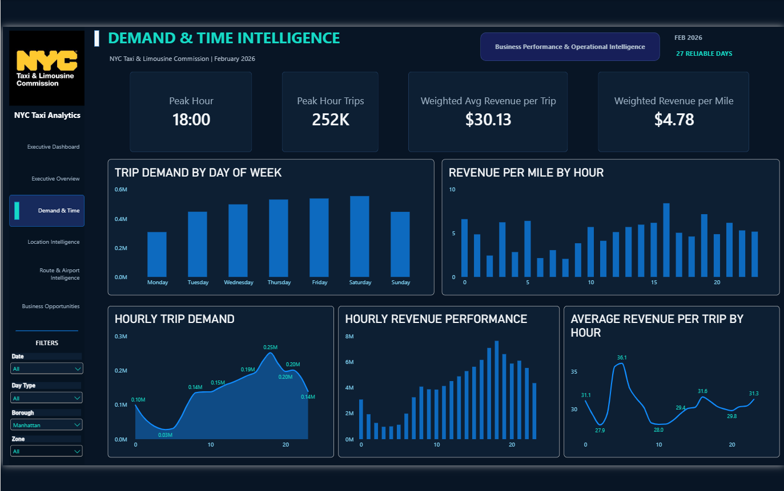

LOCATION INTELLIGENCE

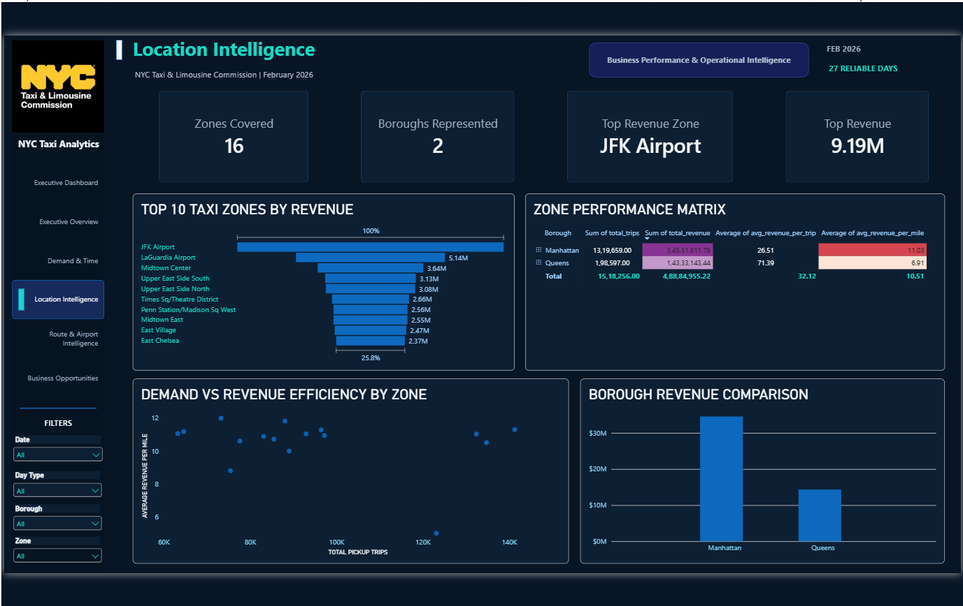

ROUTE & AIRPORT INTELLIGENCE

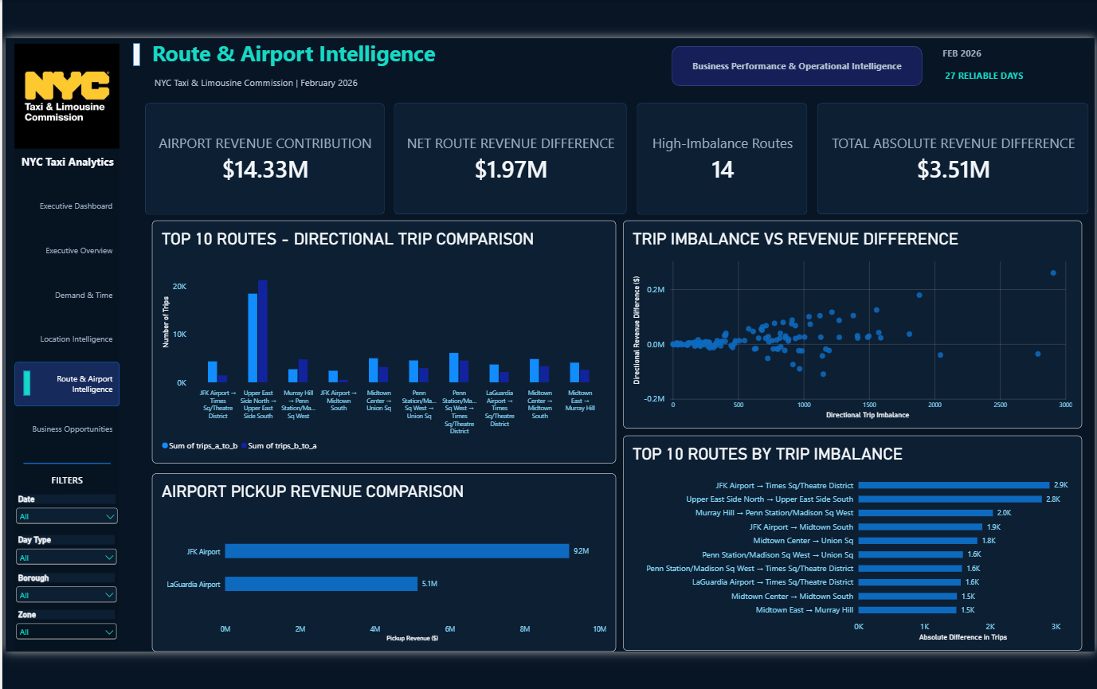

BUSINESS OPPORTUNITIES

